TUYIZERE Yvette

University of Rwanda – CST - SoICT

**Final Report Template for Web Technology Course**

***Project title: Smart Booking – Case of Final semester Project, Department of Computer and Software Engineering – SoICT, UR***

**Submitted by**: 221007271

**Year 2, CSE**

**Academic year 2023-2024**

Table of Contents

LIST OF FIGURES 2

1. Introduction 3

1.1 Project Summary 3

1.2 Problem statement 3

1.3 Objectives 3

1.4 Project Rationale 3

2. Methodologies and Methods 3

2.1 Data collection methodology 3

2.2 Tools to be used 3

2.2.1 Hardware tools 3

2.2.2 Software tools 3

3. System Analysis and Design 3

3.1 Requirement Specifications 3

3.1.1 Functional requirements 3

3.1.2 Data Requirements 3

3.1.3 User Requirements 3

3.1.4 Security Requirements 3

3.1.5 Non-functional Requirements 3

3.2 System Design 4

System information flow 4

4. System Implementation 4

4.1 Landing page 4

4.2 Login page 5

4.3 And so on, at least 5 pages of you 6

5. Conclusion 7

6. Recommendation 7

7. Appendix 7

# LIST OF FIGURES

Figure 1: Overall structure 3

Figure 2: Project landing page 4

Figure 3: Login page 4

Figure 4: List of users 5

Figure 5: User details 5

Figure 6: Edit option 6

# Introduction

## Project Summary

My project is called Smart booking.

Smart Booking will assist travelers in locating buses nearly. This bus tracking app would rely on tracking device installed on the bus to provide real-time updates on its location and estimated time of arrival. This app will help them to plan their journeys more efficiently and reducing time waiting. Smart booking will help public or private buses to book the tickets and comments on how your journey is.

This system was designed to help some farmers to sell their bananas or related products easily by introducing easiest way to connect them with customers.

## Problem statement

* There is a problem in transportation sector where you should spend an hour on the street waiting for the bus you don’t know when it is coming. When you go to buy ticket on bus station or Bus stop, you can spend 30 minutes or an hour waiting for bus. And they keep telling you that it is about to reach here. You wasted time waiting for the bus you don’t know where it is and you plan failed.
* Sometimes you weak up early morning going to school, work or any where because you don’t know where the bus is , you should miss class , your boss should fire you because none can’t tolerate someone who delay everyday . it all happens because you don’t know where the bus is and you can not afford to take private cars , you only have ticket that will take bus .

## Project Rationale

* After carrying out a simple research I found out that my project can be used to solve this problem in the following ways :
* This web app or mobile application will help people to locate the location of the bus hich is nearly. This will help them to save their time
* This web app or mobile application will also contribute to provision of jobs because every bus station will need IT who will control the system. And know where the bus in and know how many passengers booked the tickets.
* This will help passengers or society in general to be there on time and do their jobs without the pressure of losing bus .
* This web app or mobile application will help foreigners who want to take bus to know the price of tickets and know how long the journey is.

# Methodologies and Methods

## Data collection methodology

Before I used observation method because it happened to me many times. So far, after having idea of solving this kind of problem, I started to conduct some information about transportation and how to use web app or mobile application to locate the available buses so that we cannot waste time waiting .

## Tools to be used

### Hardware tools

* 1 personal computers
* WI-FI
* Smartphone

### Software tools

* Visual Studio code
* Xammp
* Github account
* Perfect working browser

# System Analysis and Design

## Requirement Specifications

### Functional requirements

* E.g.: In order to use this system , passengers, travellers or foreigners and you want us to help you to book a ticket, you need to register you self and then, after collecting your data you will be provided password to use in order to login but If you don’t have account , you may write for us anytime and we will help you.

### Data Requirements

* 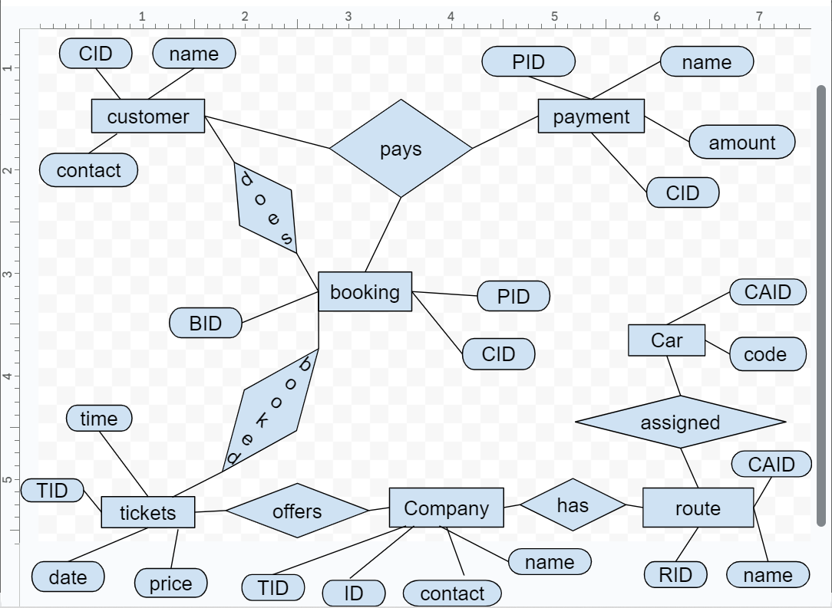

### User Requirements

* Admin, Passengers or travellers, …

### Security Requirements

* What are the security measures of your system? Password encryption, Sessions for timeout
* In order for someone to enter to his dashboard especially admin and traveller or passengers must provide email or telephone number and password as they have registered,…

### Non-functional Requirements

* What is the system performance?
* My system’s performance is not hundred percent because it is still in progress….
* What is the system reliability?
* My system is realistically because it is simple to use
* What is the system accessibility?
* Through consideration of accessibility I thought of illiteracy people who are not able to use emails they can use telephone number or visit our site and directly meet who can help you to book your ticket.

## System Design

### System information flow

Once a traveller wants to wants use this web app or mobile application he or she must sign up and after he will be able locate the available buses nearly.

# System Implementation

* Some screenshots.

## Landing page

This picture detail the landing page of the proposed project. From this page explain to you about this app and the Ritco company we are working in details.

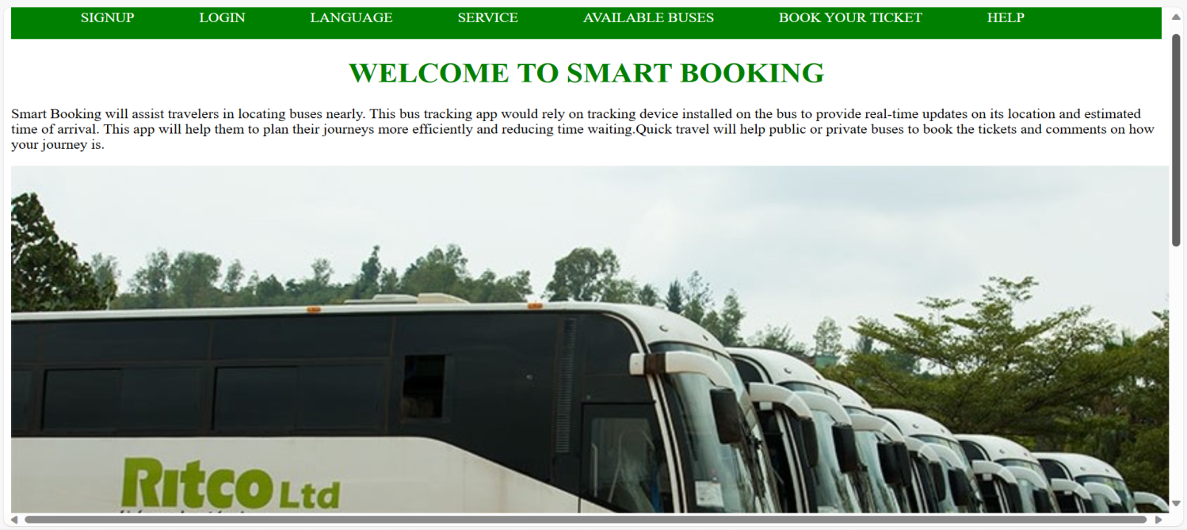

Figure1: Landing page

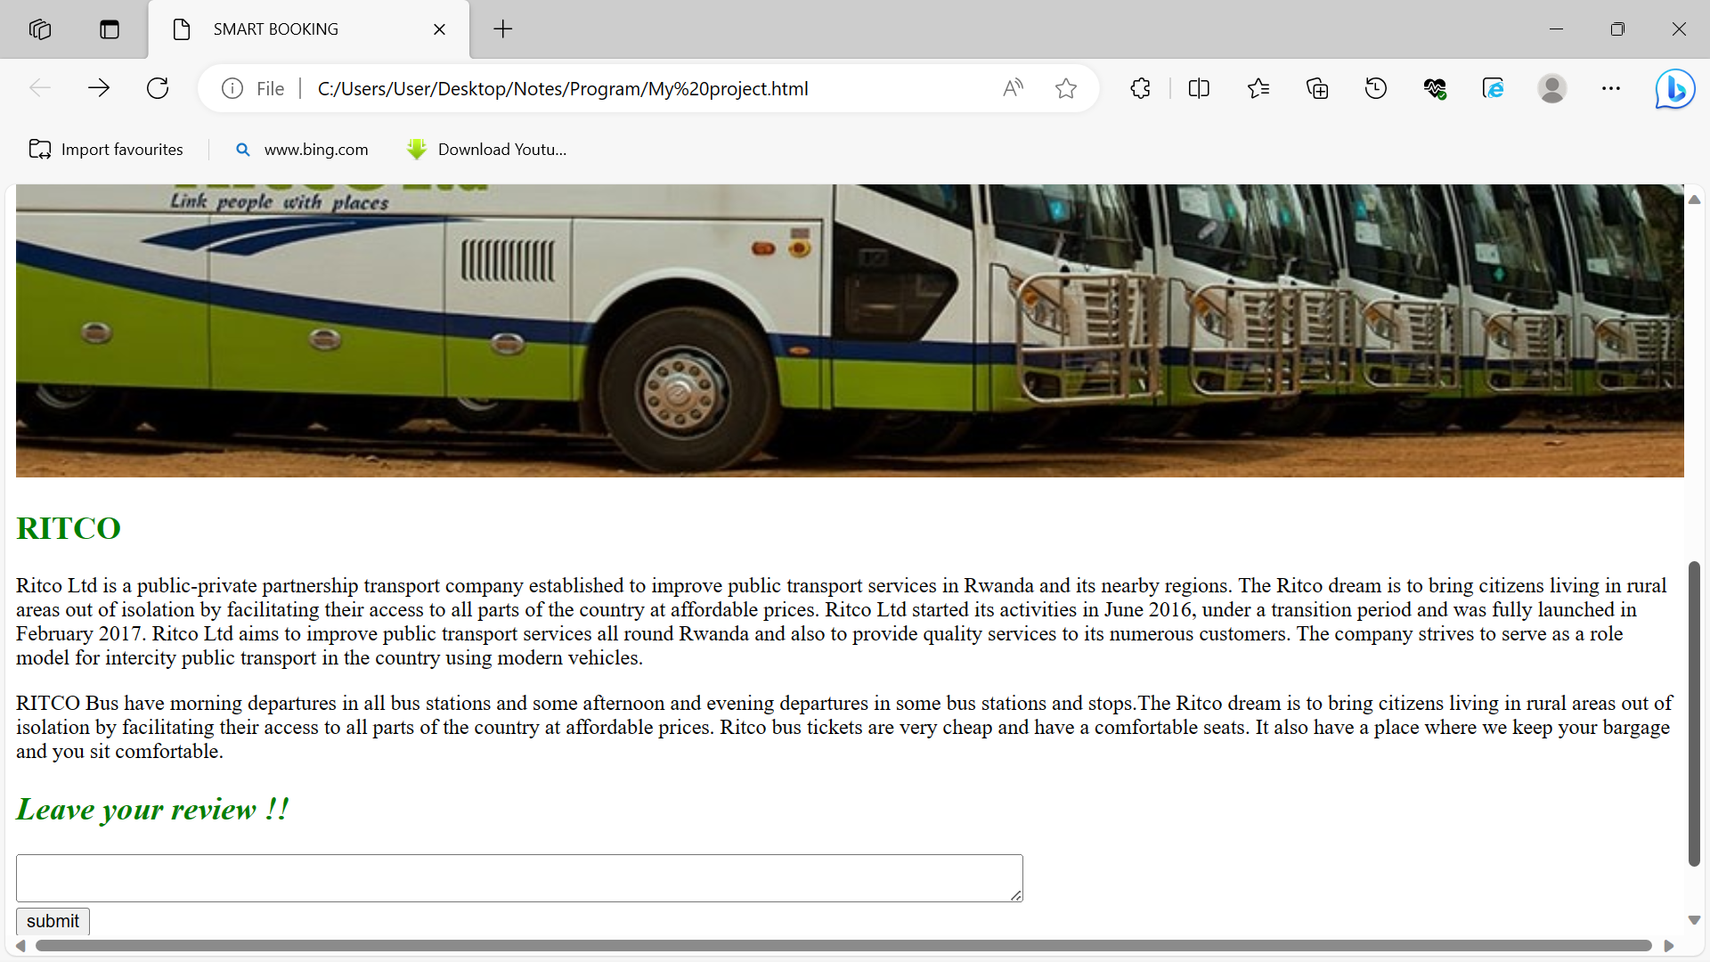

Figure 2: Project page you can to leave your review

## Login page

This page detail the login process of the proposed project. This page detail the login process of the proposed project. This page detail the login process of the proposed project.

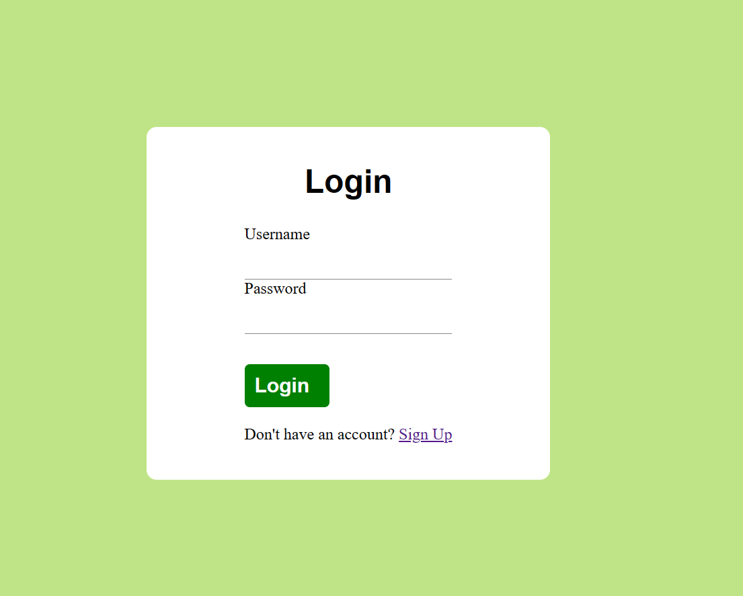

Figure 3: Login page

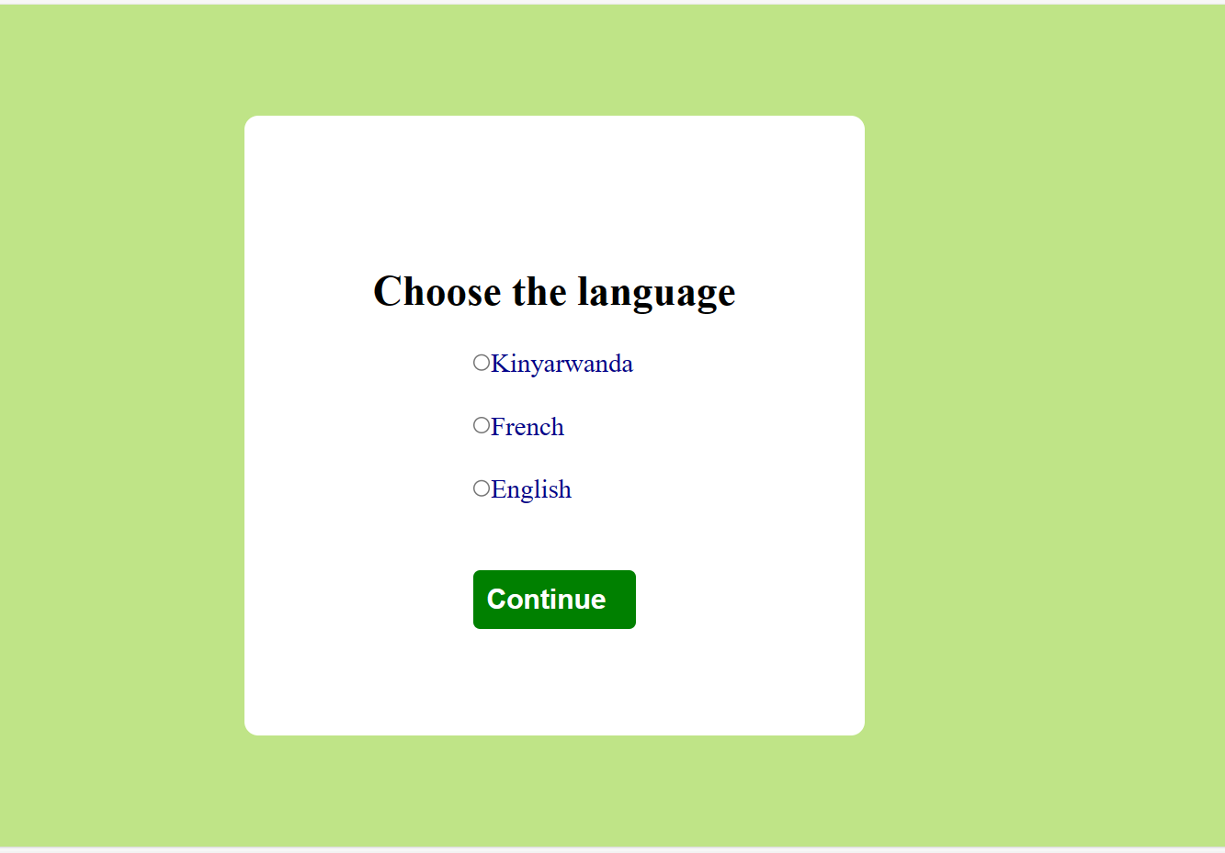

Figure 4: language page

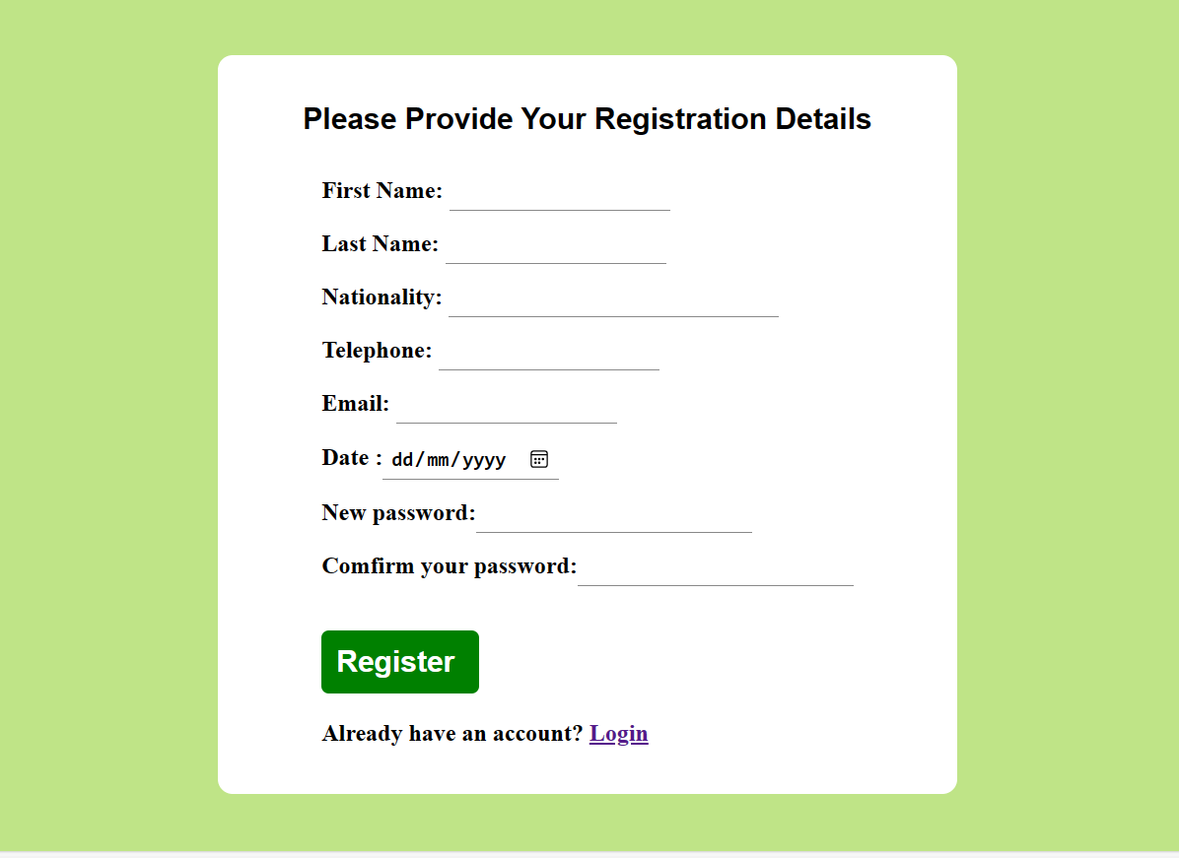

Here comes my sign up form

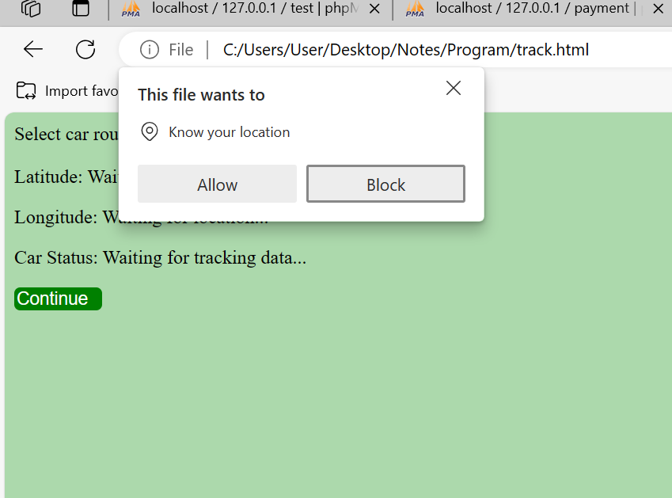

This image shows one of the use of java script in my project

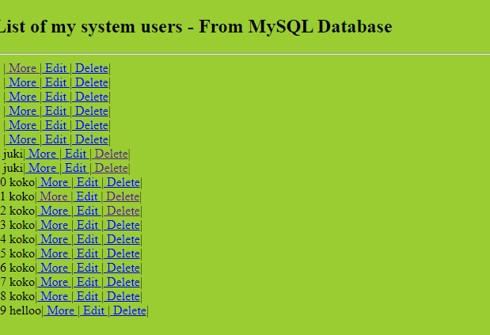

# Conclusion

* As conclusion, I wanted to implement this project 100%, but I couldn’t do it as usual I implemented it like at 60% .Because all about front end is finished while back end still have a lot to do and wish to complete it . As beginner I do have a serious blocker on backend side I still need to read more about so that I will be able to accomplish my project. I’m very sure that after finishing my project completely will be helpful to the society.

# Recommendation

* The most thing I learned from this project is that, first of all I should be a best problem solver
* Secondly is that once my dreams is all about coding I still have long journey to travel but above all that, I’m very excited with this kind of teaching strategy ,It helped us a lot .
* What I can ask as benefits for next promotions is that please ask for us whether it possible to increase the time we spent in this kind lessons especially practice about our field.

It will be a great pleasure the time we will be having huge number of students who are able to beneficiate our society as well as the country by introducing this kind of solutions .

# Appendix

* Link for your GitHub account with your project, if there is a need of password share it too.
* <https://github.com/angepauline/bananaassignment.git>
* Checkout the codes on a branch called new1